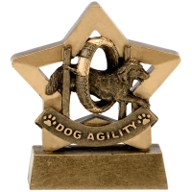
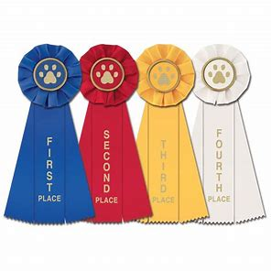
BORDABEARS
DOG TRAINING CLUB

Presents
COMPANION SHOW BONANZA
SUNDAY 2ND JUNE 2024
PELHAM HOUSE FARM, HABROUGH DN40 3AX
Entries from 10am - £2 a class
Pedigree classes from 12pm

Fastest Recall
Have a go Hoopers,
Tennis ball game
Steeplechase
Tunnel exchange
Pairs jumping.

- Puppy
- Sporting
- Non Sporting
- Open ( open to all pedigree dogs)
- Veteran
Companion Classes from 2pm
- Cutest Puppy
- Best Adult Dog (1-6 years)
- Golden oldie (7 plus)
- Prettiest Bitch
- Handsomest Dog
- Waggiest Tail
- Best Family ( 2 or more dogs related or living in the same household)
- Best Crossbreed
Catering van
Kj’s Rotisserie Chicken

- Best Child Handler (14 years and under)
- Best Rescue
- Best Trick
- Best Six Legs
- Best Brace
- Best Condition
- Best Sausage Catcher
- Best Fancy Dress
- Most Unusual looks
- Dog the Judge would like to take home
Rosettes 1st-6th in each class
Trophies for BIS, RBIS, BP, BV, Best Pedigree, Best Novelty,
and Best Child Handler.
Catch the Memories photography will be in attendance
for more info go to www.bordabearsbordercollies.weebly.com

